**On-prim AD to Azure AD Sync up**

**Client requirement:**

1. Creation of new domain on azure “eccouncil.org”
2. Synchronization between Azure directory “eccouncil.org” and on premises active directory “eccouncil.org”.

**Creation of new domain (**eccouncil.org**):**

Step1: Sign in as a global admin

Step2: Select custom domain

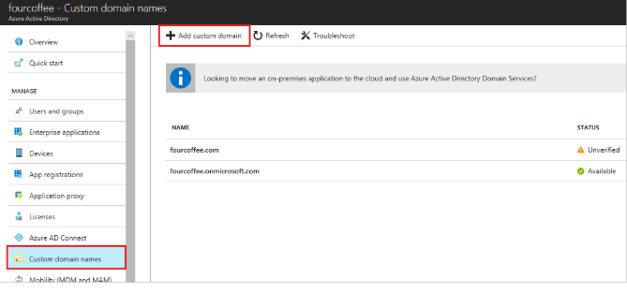

Step3: On Custom domain names, enter the name of your custom domain in the box, such as ' eccouncil.org ', and then select Add Domain. Be sure to include the .com, .net, or other top-level extension.

Step4: On domain name (that is, your new domain name is the title), gather the DNS entry information to use later to verify the custom domain name in Azure AD.

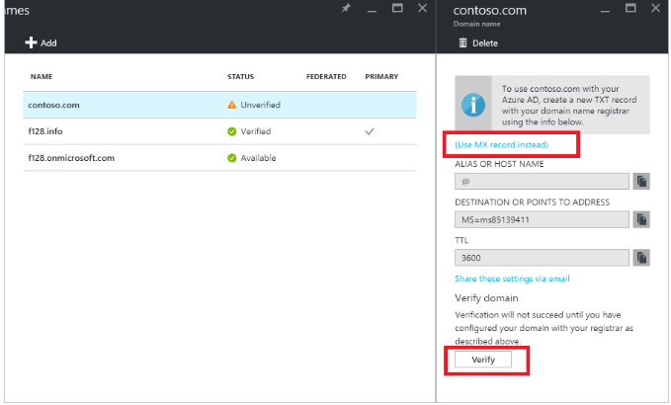

Step5: Add a DNS entry for the domain name at the domain name registrar using creating a TXT record or MX record.

Step5: After that, click on **verify** button.

Step6: After domain verification, make that domain as primary.

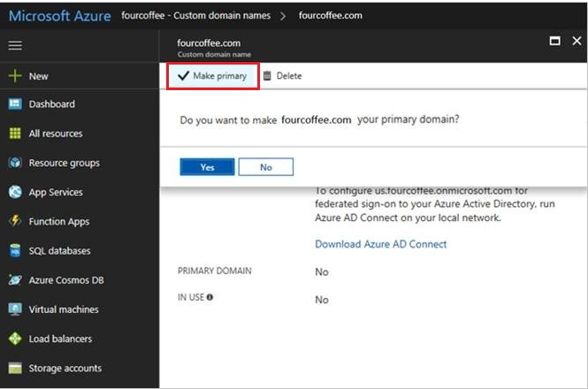

Step6: After making a primary domain I create one global admin user.

Step7: Login to Active directory

Step8: Download Azure connect and install in on prim Active directory

**For Installation, follow the steps:**

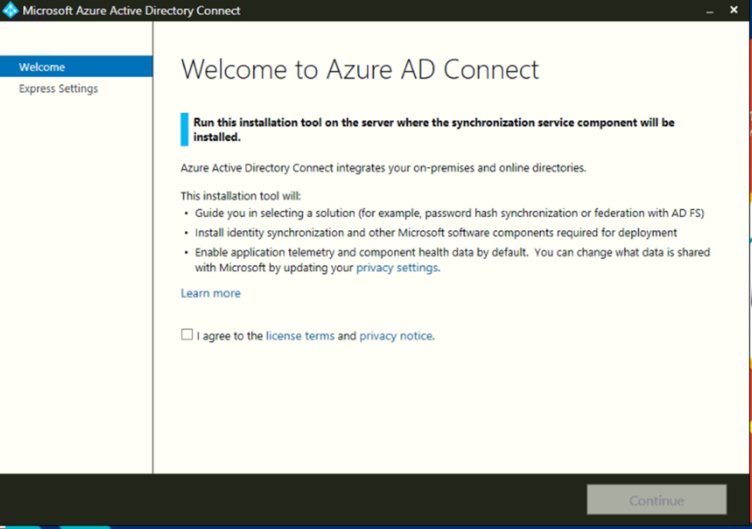

* Select Check box the agree license.

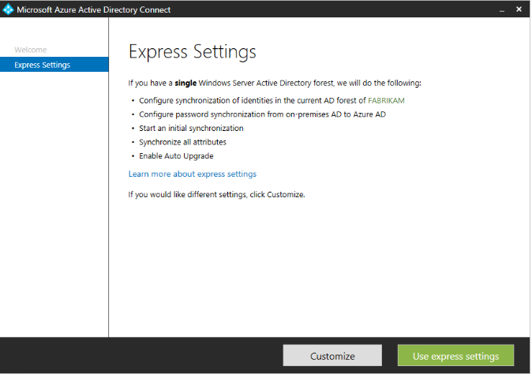

Used express route setting as per client need.

* On the Connect to Azure AD screen, enter the username and password of a global administrator for your Azure AD. Click Next.
* On the Connect to AD DS screen, enter the username and password for an enterprise admin account. You can enter the domain part in either NetBios or FQDN format, that is, FABRIKAM\administrator or fabrikam.com\administrator. Click Next.

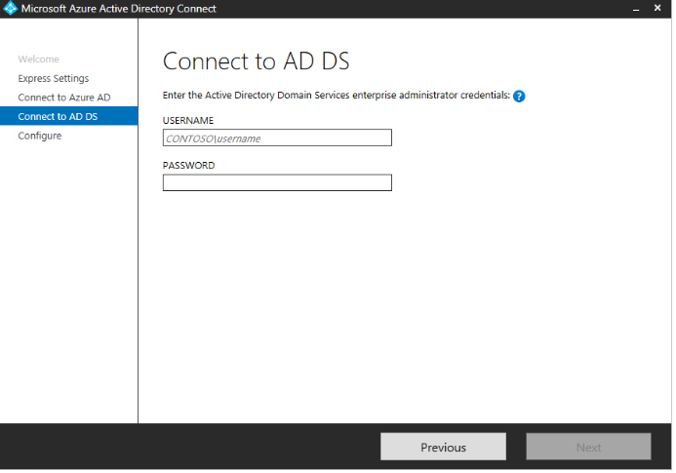

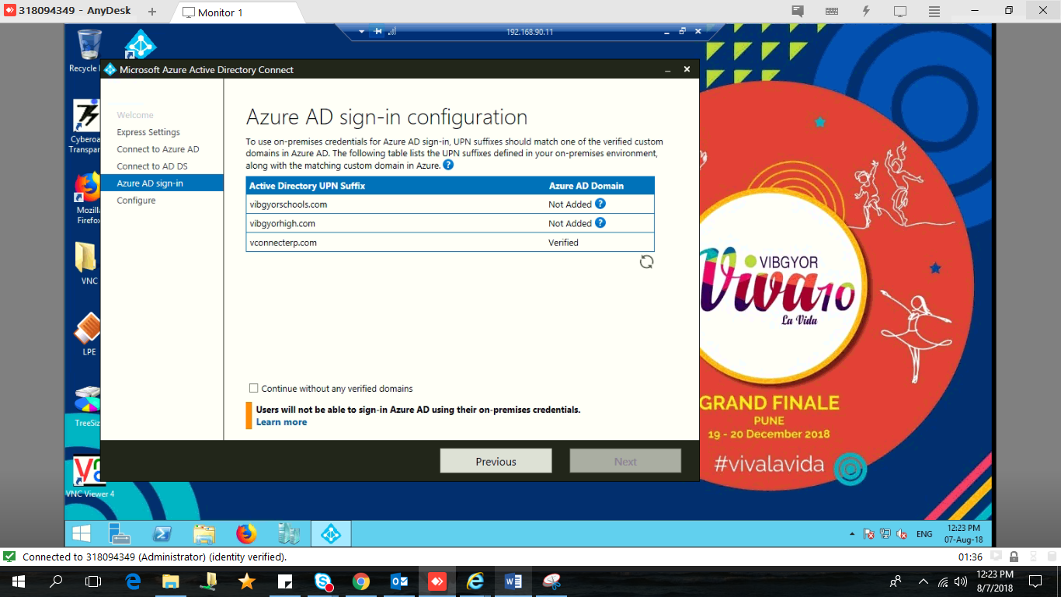

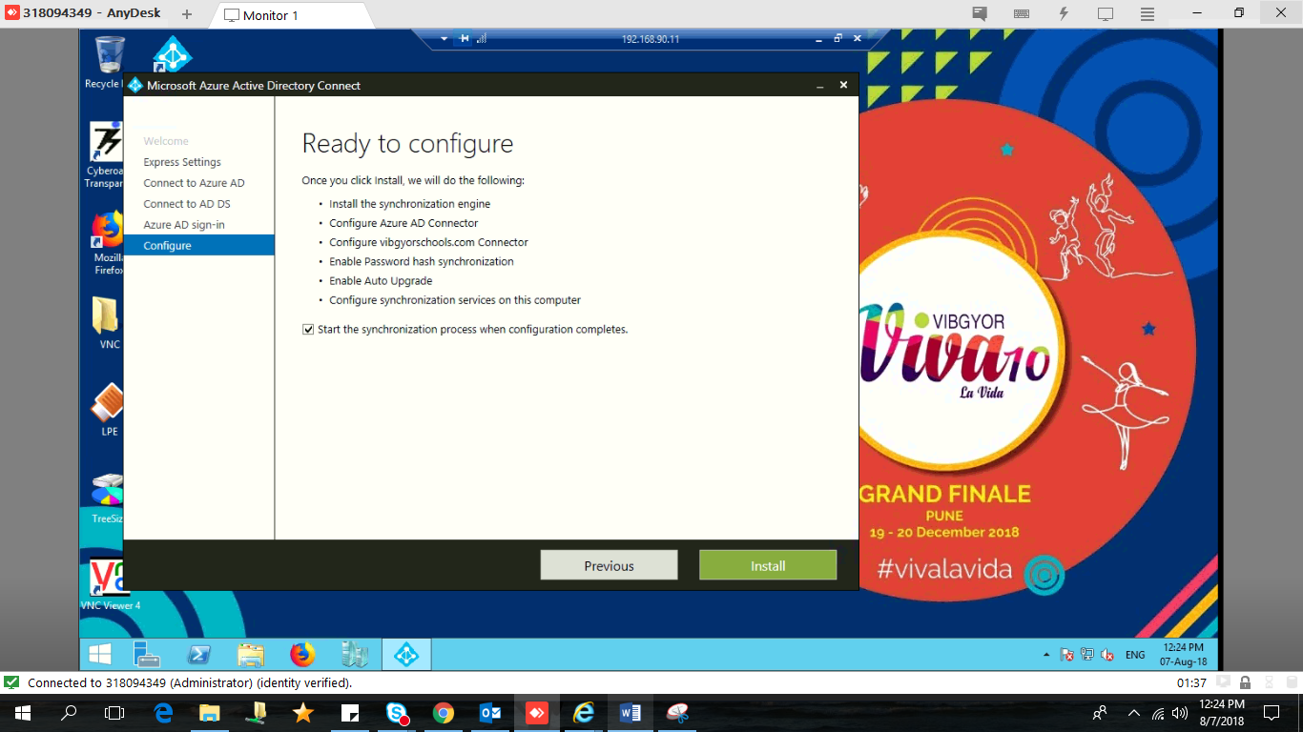

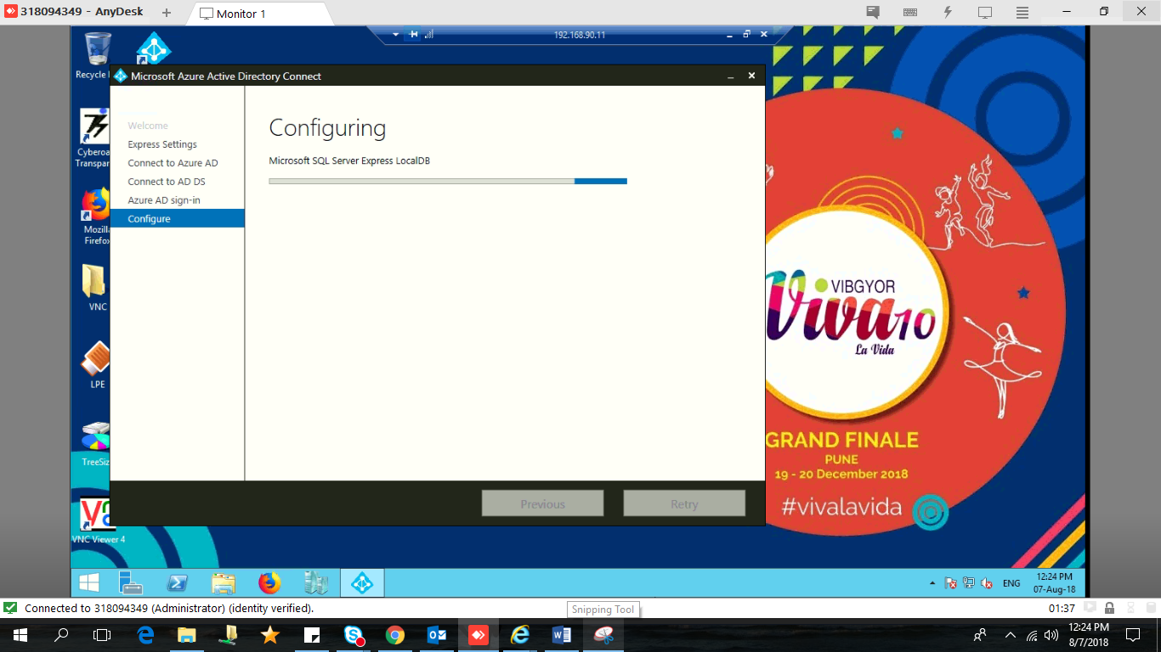

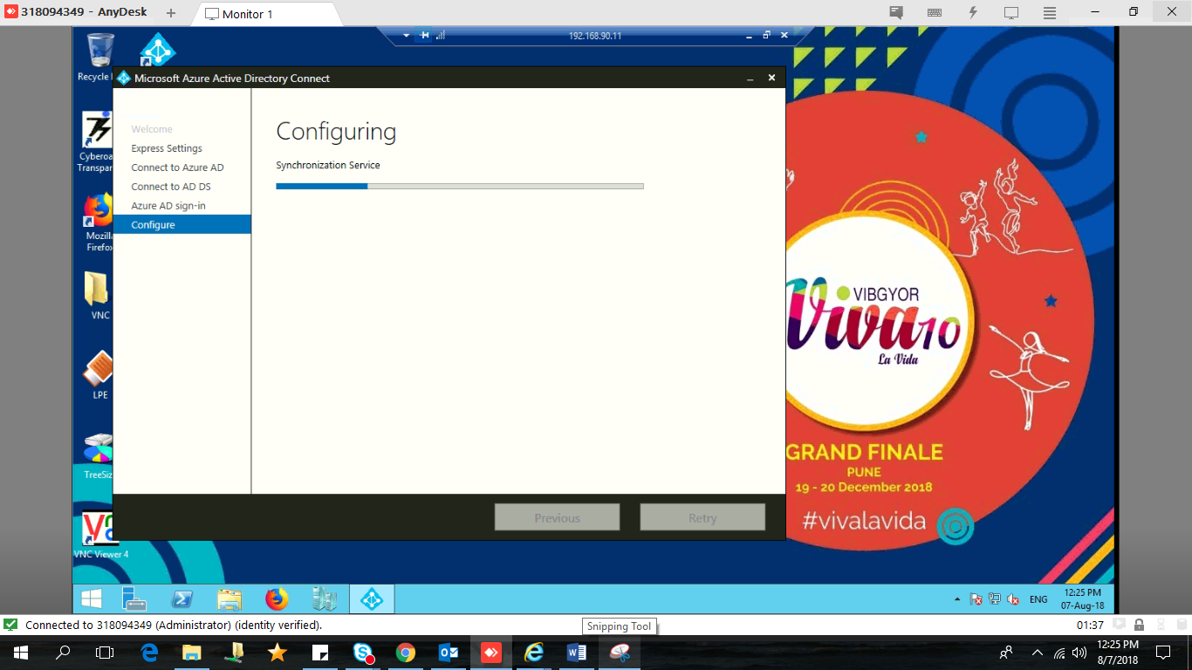

After installation, sync enabled between on-prim AD to Azure AD so on-prim users will sit in the Azure AD.

**Reference:**

You can use Azure AD connect if you want to sync from On prim to Azure.

<https://blogs.technet.microsoft.com/canitpro/2015/07/13/step-by-step-setting-up-the-new-azure-active-directory-connect/>

<https://www.codetwo.com/admins-blog/how-to-sync-on-premises-active-directory-to-azure-active-directory-with-azure-ad-connect/>

In addition, it would be helpful if you can make documentation of Azure AD.

For custom domains please refer the link in the below mail.